PORTFOLIO

Please visit portfolio of Web Site/Web Applications. Any questions please call me or email me.

 | http://www.vx.com  Mainly uses ColdFusion/PHP/MySQL backend (on Windows)  See the show-n-tell, image gallery, testimonial, news release, etc.  I was technical lead and developer for this site.
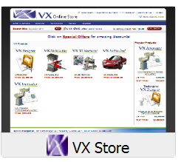 | Mainly uses ColdFusion/PHP/MySQL backend (on Linux)  This is integration of sitedirector (quilldesign.com) storefront with SoftTrax finance and GoldMine CRM databases. I was technical lead and developer for this site.
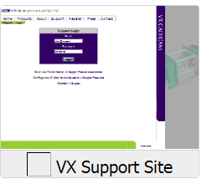 | This is VX Intranet /Customer Support Site  Build with ColdFusion 8/MSQL/MYSQL  All business critical web application reside here.  I developed and maintained the site since 1999
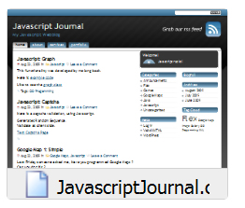 | http://www.javascriptjournal.com  Check the online presenter tool  http://javascriptjournal.com/ws/?tag=flex  This is LAMP (Linux, Apache, MySql, Php) Site
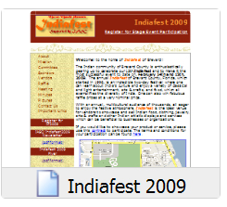 | http://www.indiafestbrevard.org  This site and designed, developed and maintained by me since 2005.  This is LAMP (Linux, Apache, MySql, Php) Site
CERTIFICATES

http://www.experts-exchange.com/M_3560142.html

BrainBench Certificates

SKILL MATRIX
Skill | Years | Last Used
ColdFusion (v4.5, MX, 8,9 ) including CFCs, Framework | 8 | 2010
JavaScript | 8 | 2010
T-SQL | 5 | 2010
XML/XSLT (some SVG,XSD) | 5 | 2010
Flex 3 | 3 | 2010
SQL 2000, 2005, 2008 (some MySQL) | 6 | 2010
HTML/CSS | 7 | 2010
Web Server and Database Server Installation, Administration | 5 | 2010
Requirements and System Analysis and Software Design | 10 | 2010
OO programming | 10 | 2010
Project Management/ Technical Leader | 10 | 2010
C/C++ | 8 | 2010
QA Automation Testing | 2 | 2010

